**Angie’s Antiques Database Proposal**

|  |
| --- |
| **Client Company** |
| Angie’s Antiques |
| 1666 Alki Ave SW |
| Seattle, WA 98116 |

|  |
| --- |
| **Consulting Firm** |
| Corey Crooks Consulting |
| 1638 Palm Ave SW |
| Seattle, WA 98116 |

This document was prepared by

Corey Crooks

coreycrooks@student.purdueglobal.com

November 15, 2023

**Executive Summary**

Angie’s Antiques is a small business that is looking to develop a database to hold company information regarding sales, clients, and more. Angie’s Antiques currently has the budget for three employees total. Unfortunately, database management is not simple and requires intermediate levels of scripting and troubleshooting. Angie’s Antiques does not have the budget, manpower, nor time to incorporate an on-site server platform with digital database integration for the point of sales system. Because of these business challenges, I would recommend an online environment. Specifically, Amazon’s AWS platform leverages off-site resources to store company data that Angie’s Antiques could use efficiently. This platform also leverages a “pay as you go” scale to eliminate unnecessary costs.

**Objectives**

* Develop a database system that can store company and client records.
* Incorporate a database system that utilizes minimal troubleshooting time for a limited pool of employees.
* Deliver a database system that can be used at-will with minimal cost to the company.
* Deliver a database system that does not require an over-haul of the antique shop such as implementing a designated server room.

**Strategies/Methods**

The scope of this project is relatively straightforward. Angie’s Antiques is a small business with three employees. Because of this, the shop isn’t capable of advanced level IT mechanics such as advanced SQL query troubleshooting, or database recovery. The database that is delivered should be able to be simply maintained by a team of three individuals that have up to entry level experience. Due to this being an antique shop, much of the floorspace of this company will also be taken up by the show room floor. For that reason, this database should be limited in the space it takes up in the given establishment to make room for potential revenue generating artifacts.

Delivery on this project should be equally simple. Cloud computing and storage does not require room in the establishment outside of the host computer to connect, and space for internet equipment such as a modem. This process should take limited time and resoruces as the main effort here would be creating and implementing the software side of AWS functionality.

**Human Resources**

|  |  |  |
| --- | --- | --- |
| **Name** | **Job Title** | **Company Association** |
| Angie Smith | Buisness Owner | Angie’s Antiques |
| Isaac Clarke | AWS DynamoDB Consultant | Amazon |
| Corey Crooks | IT Consultant | IT Consultation Agency |
| Leon S. Kennedy | IT Tester | IT Consultation Agency |
| Alan Wake | NoSQL Automation Expert | IT Consultation Agency |

**Schedule**

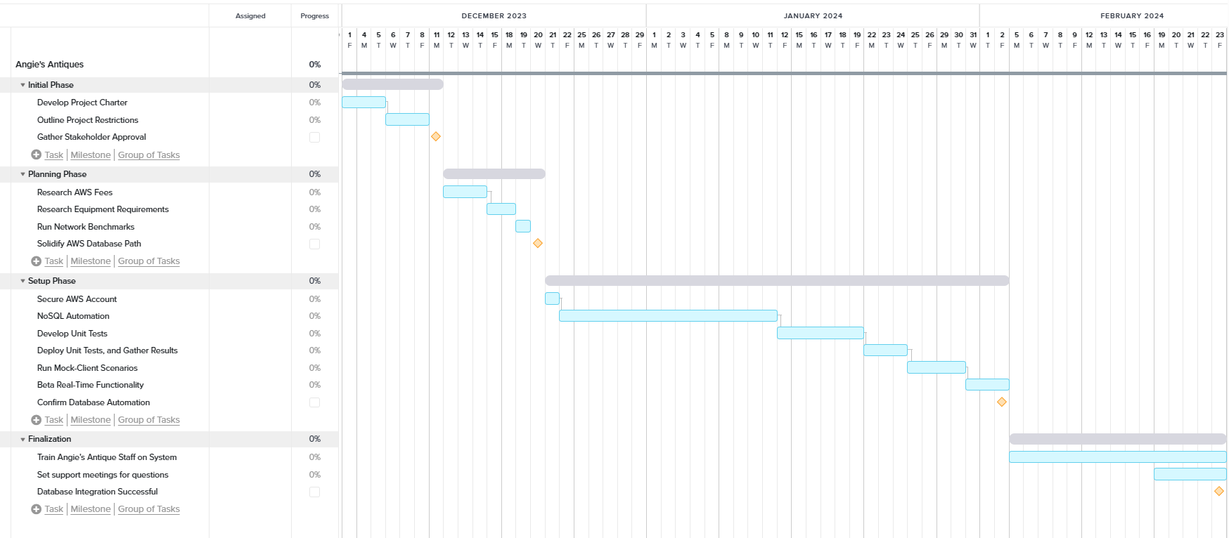

**Costs**

|  |  |  |
| --- | --- | --- |
| **Object** | **Price Range ($)** | **Charge Frequency** |
| Modem | 60-400 | Once |
| Router | 60-400 | Once (depending on wireless need) |
| Host computer | 600-1500 | Once |

|  |  |  |
| --- | --- | --- |
| **Phase** | **Estimated Hours** | **Expected Cost ($)** |
| Initial | 112 | 2,800 |
| Planning | 112 | 2,800 |
| Setup | 1024 | 25,600 |
| Finalization | 360 | 9,000 |

**Total Labor Cost:** $40,200

|  |  |  |
| --- | --- | --- |
| **Service Name** | **Estimated Cost ($)** | **Charge Frequency** |
| Internet Subscription | 80 | Per Month |
| DynamoDB Subscription | 5* | Monthly |

*Number based on projected Read/Write needs of a small buisness.

**Methods of Communication**

Replace this sentence with your content per the assignment instructions.

**Approvals**

Consultant Corey Crooks Date November 15, 2023

Client Date

**Appendix**

**Proposed Entity Relationship Diagram**

